***Data Analysis Queries for Financial Loan Dataset***

1. **Count the top 3 states with highest number of customers**

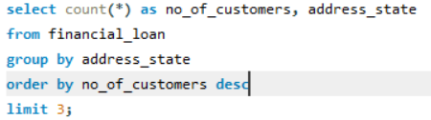

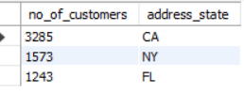

1. **Rate of the number of customers who are charged off**

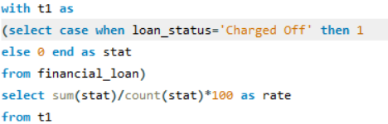

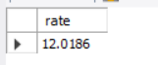

1. **How many customers’ loans were charged off who owned a hom**e?

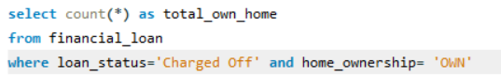



1. **List of customers who have an annual income more than 100000 and have loan status declared as charged off**

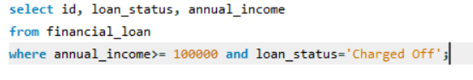

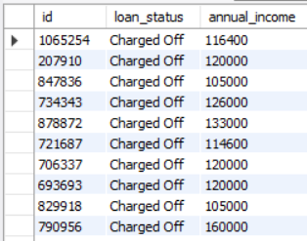

Total 217 rows returned out of 17398 rows

1. **Which emp_length group has the maximum number of customers with charged off loan status?**

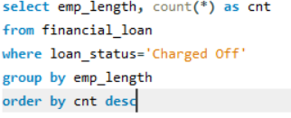

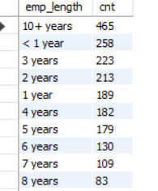

1. **Total due amount for the company**





1. **Total charged off money value**

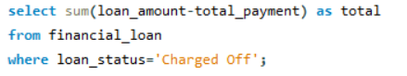



1. **What is the term of payment for the highest annual income earning person?**

